STAATSKOERANT, 2 JUNIE 2017 No. 40883 249
BOARD NOTICES . RAADSKENNISGEWINGS

BOARD NOTICE 98 OF 2017
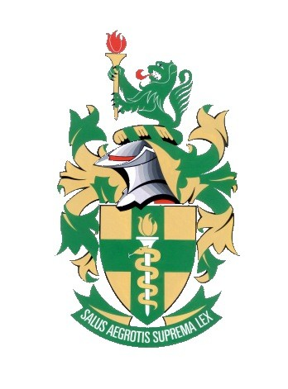
The Allied Health Professions Council of South Africa
Castelli Suite, Il Villaggio, 5 de Havilland Crescent South, Persequor Technopark, Pretoria
Telephone (012) 349 2331 Fax (012) 349 2327
Email: registrar@ahpcsa.co.za Website: www.ahpcsa.co.za

19 May 2017

PROFESSIONAL BOARD: AYURVEDA, CHINESE MEDICINE AND ACUPUNCTURE AND UNANI TIBB: THE USE OF NEEDLES: UNPROFESSIONAL CONDUCT

The Allied Health Professions Council of South Africa after due consideration and in consultation with the Professional Board: Ayurveda, Chinese Medicine and Acupuncture and Unani-Tibb (PBACMU) has resolved that –

- The reuse of single use needles is unacceptable as it puts patients needlessly at risk and it therefore constitutes unprofessional conduct on the part of the practitioner concerned. Practitioners are required to observe at all times the safety requirements associated with the use of needles and to use needles only in accordance with the manufacturer’s recommendations and to dispose of such appropriately.

- The use of blade needles currently falls outside the scope of practice of Acupuncture. The use of such needles will therefore constitute unprofessional conduct until such time as their use is included in the scope of practice for Acupuncture and proper education and training for the use of blade needles is available.

DR LOUIS MULLINDER
REGISTRAR

This gazette is also available free online at www.gpwonline.co.za

